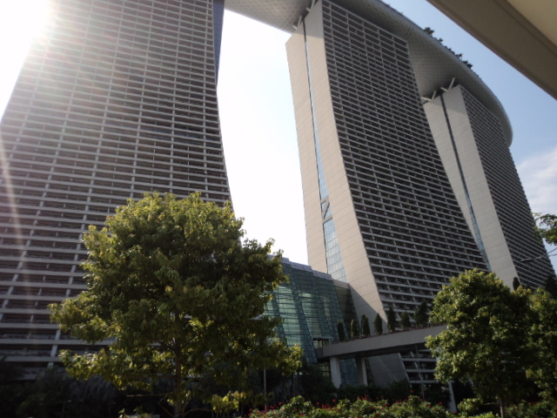

As can be seen above, Gardens by the Bay is next to the Marina Bay Sands Hotel in Singapore’s BAYFRONT MRT STATION. Clear signboards welcome and greet the tourists and visitors alike, signposting every direction of each nook and cranny of the island. Indeed, it is a rare sight to behold, where a giant surfboard is placed on top of the two MBS Hotel buildings. Anyway, our destination guide for today focuses on the adjacent FLOWER GARDEN & CLOUD FORESTS, whose photographs litter the following pages of this review. Tickets are priced at 28 dollars for adults and 15 dollars for children below 12 years of age.
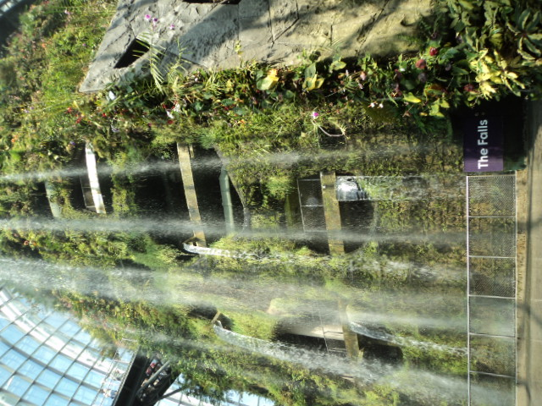
This is reportedly the highest man-made waterfall in Singapore! My skin felt chilly as the drizzles evaporated in the afternoon sun on my body. Artificially-created, this is a remarkable attempt at recreating Mother NATURE, while capturing the magnificence of natural wonders such as the insects, smell, aromatic leaves and flowers, colourful flora and fauna of the region. I had to stretch my neck to catch a glimpse of the tall manmade waterfall, but it was truly captivating a sight to behold!
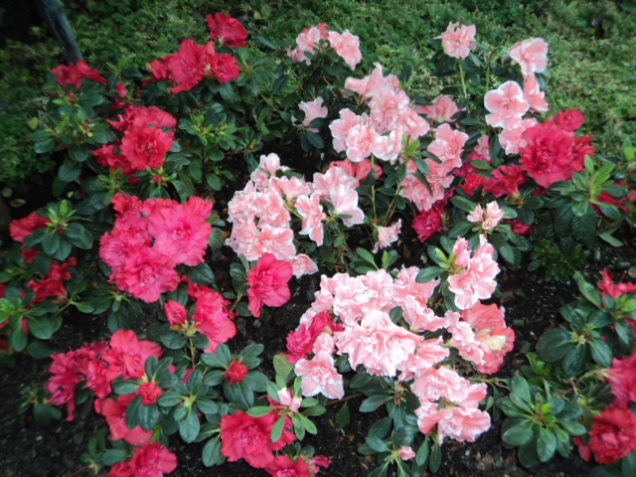
Next on our list were the multi-coloured begonias, whose sweet smelling aroma delighted our presence in every possible way. You can snap away at these pretty flowers without getting caught for trespassing, since flowers are the highlight of this FLOWER GARDEN DOME-SHAPED CONSERVATORY, which spans several acres each. A true treat to the eyes and nose, we spent hours clicking our cameras away at the rarest collection of flowers presented here. As Wordsworth’s famous poem goes, the brightly-coloured daffodils danced in glee as though they were greeting me on such a pleasurable afternoon, as I watched on in a joyous mood.
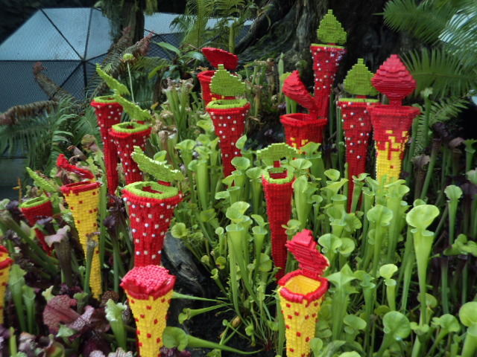
In stark contrast, we arrived at the carnivorous Venus-flytrap plants and the pitcher plants that feed on dead insects and decaying matter! Mother Nature is not so sweet after all; she can be cruel if need be. After all, it is the survival of the fittest in natural worlds such as these. Nonetheless, they were a colourful appearance and seemed genuinely benign to the curious onlooker. Little does one suspect rancid putrid acrid ACIDS are contained within these plant saplings to digest and kill its living prey bit by bit!
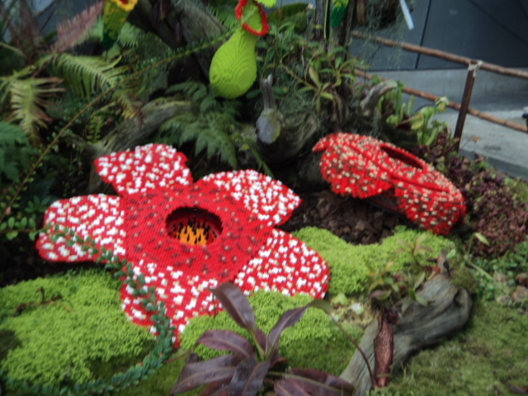
Another rather unpleasant finding was the Rafflesia, the world’s largest but stinking flower located typically in Malaysian territories. It gave off a pungent stench but was large enough for me to sit on and play or caress it! Being red in colour, it betrayed its attractive appearance by emitting the foulest smell coming off a flower! I wonder and marvel how these RAFLLESSSIAS were shipped across the Causeway checkpoint?!
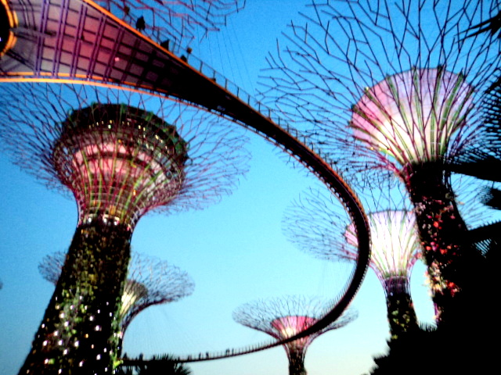
Finally, it was night time and time for the Symphony Orchestra Music Show at the BAORDWALKS. We were immersed in 20 minutes of aural pleasure and delight, as the two humongous trees lit themselves up in accordance to the nationalistic songs that were played in the background to mark Singapore’s SG50 HALF-A CENTURY OF INDEPENDENCE! Indeed, it was all not easy effort or child’s play; every lightbulb and every song was carefully and intricately selected to enthral its audience in glee. You cannot miss this beautiful place for sigh seeing. Grab your tickets to Singapore now! Hurry up! What are you waiting for?!

